Hotel Management System

Application Functionalities:

Admin/Reception

User

Staff/Employee

Admin:

1. No of Users
2. No of Employees
3. Collections : Payment status
4. Add New Employee/ Delete the employee
5. Reports - Financial
6. Reports - General
7. Daily In and Out Customer Management
8. Add new Users / Delete the Customer
9. Add/Remove Offers
10. Take Feedback
11. Check the availability of rooms/Halls/etc.

User:

1. Registration to the website
2. Login to the website
3. Book The room
4. Check the availability
5. Pay the Fee online
6. Offers/Coupons
7. Feedback

Staff/Employee:

1. Login
2. Check/Update Their Work
3. Feedback/Complaint about Hotel.

Er Diagram for Admin:

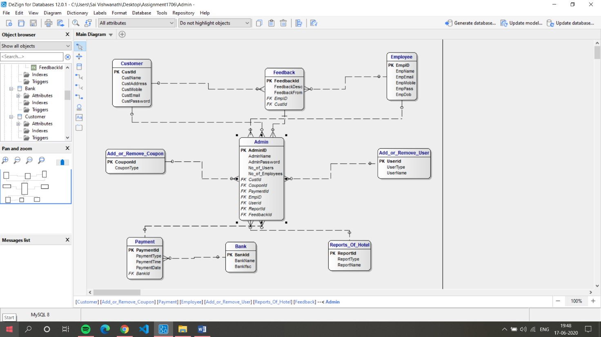

Er Diagram For Customer Module

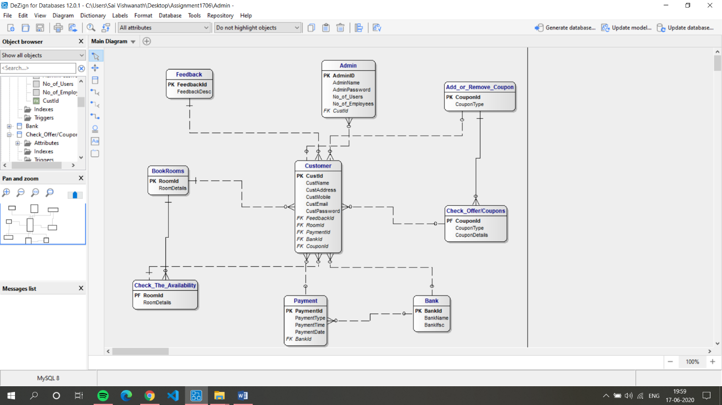

Er Diagram for Employee Module

